The Slime Pit Of Doom Promo Speech

  - Ravi’s World
Hello guys, its Ravis World, and I made a game in PenguinMod. It’s called “The Slime Pit Of Doom,” based on Raviolo The Magician’s “Slime Pit Of Doom.” If you haven’t heard of Raviolo The Magician, you don’t need to, as getting stuck in slime originated in the early 1900s with comics featuring slime-like creatures, however, the most popular example of getting stuck, or covered in slime was in the golden age of Nickelodeon; they would release the show “You Can't Do That on Television”, followed by “Double Dare” a game show in which, according to Wikipedia, two teams compete to win cash and prizes by answering trivia questions and completing messy stunts called physical challenges. This trend would then transfer over to TV Shows and works of art by individuals.
Examples (shown in video, not spoken about):
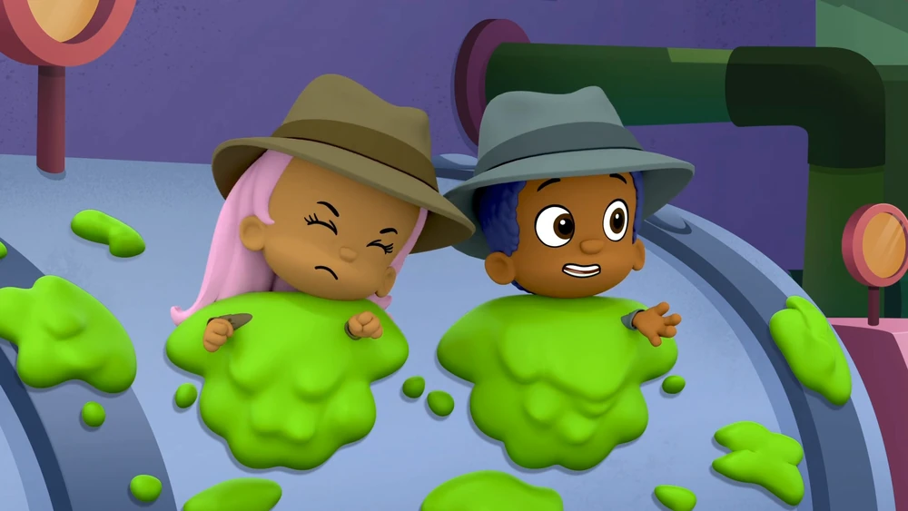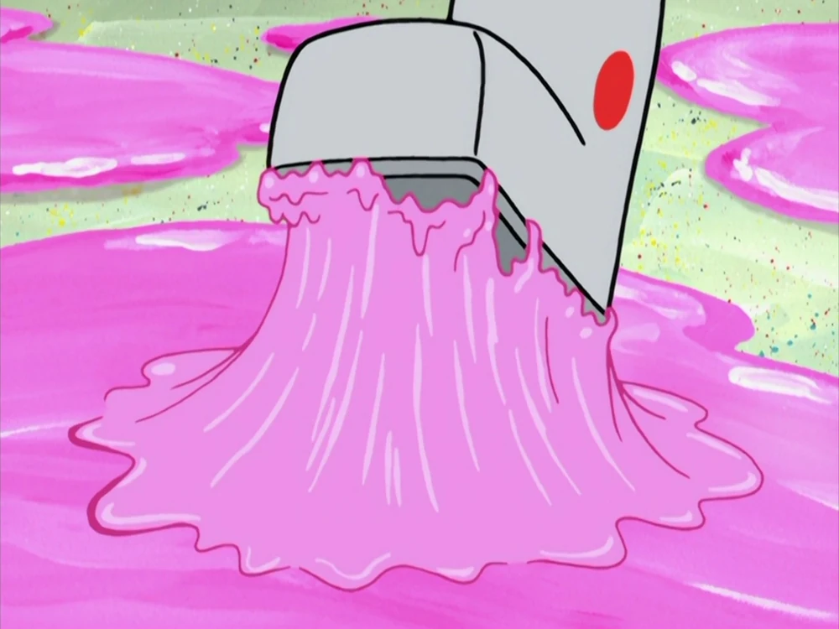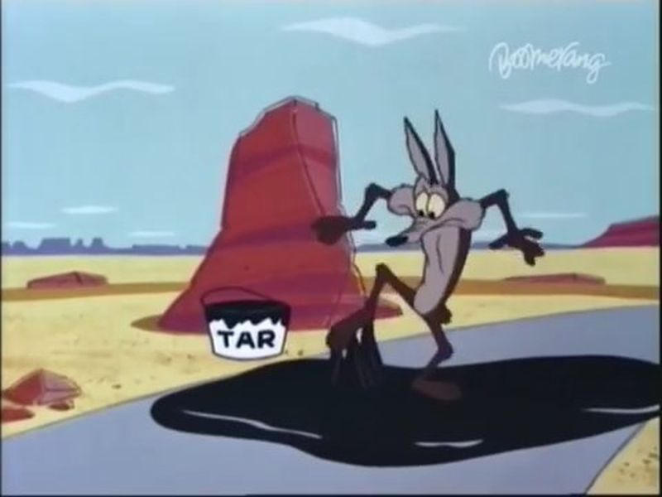
But we’re here today to talk about my game. Also, for the feet, I used Scratch Cat’s feet, but skin coloured. You start by choosing a number that corresponds to the type of pit, for example, 1 is Slime, 2 is Mud, 3 is Tar, etc. Then you choose whether you want to have grunting dialogue, not audio, dialogue. Then you choose the maximum length of time you want the feet to strain for, with the minimum being 6, capping at 10, and defaulting to 10 if an unacceptable answer is given. Then you watch the action. As you can see, the feet are lifting and straining for a certain length of time, then plopping back down again with gooey sound effects, which, one of them was taken from Pixabay. I plan to add more slime pits soon and try to make a sequel to the game called “The Stomping Grounds.” I will let you listen to the rest of this animation uninterrupted. See you.

